Name Date Period

Principles of Ecology – Chapters 2, 3 and 4

- Ecology
  - Define ecology.

  - What is the difference between biotic and abiotic factors in an ecosystem?

  - Identify 3 examples of both biotic and abiotic factors in the rainforest.

- Ecological Levels of Organization
  - The is the portion of the Earth which contains life.

  - In order from smallest to largest, what makes up the biosphere?

→ → → → → BIOSPHERE

  - For each level of organization, describe and give an example of its contents.
 | Organism | Population | Community | Ecosystem | Biome | Biosphere
Description
Example(s)

- Terrestrial Biomes
  - Identify the four major categories used to classify a biome.

  - List the terrestrial biomes.

  - Chose a terrestrial biome and describe its temperature, rainfall, plants and animals.

  - Can you think of any adaptations plants in the coniferous forest might have?

  - Use the top left graph to answer the following question: Which biome has an average annual precipitation of 150cm and an average annual temperature of 10°C?

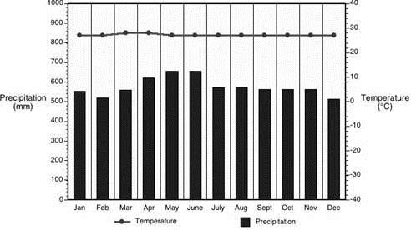
  - Use the top right graph to answer the following question: Which biome would you expect to find closer to the equator, the temperate deciduous
forest or the coniferous forest?

  - You would expect the climatogram seen to the right to represent data from which biome?

- Aquatic Biomes
  - Approximately % of all water on Earth is salt water.

  - The most biodiverse aquatic ecosystems, both freshwater and marine, are the shallowest zones. Why are these zones able to support such a large number and variety of living organisms?

- Ecosystem Interactions
  - Define habitat.

  - An organism’s niche is the that an organism has in its environment.

    - Give an example of an organism’s niche.

- Community Ecology
  - A limiting factor is anything which limits the size of a population. Give 4 examples of limiting factors.

  - What is the maximum number of a certain species that an ecosystem can hold?

  - The graph illustrates an ecosystem with a carrying capacity for approximately deer.

  - What is the difference between density dependent and density independent limiting factors?

  - Give 2 examples of each, density dependent and density independent factors.

- Ecological succession
  - Describe ecological succession.

  - Primary succession takes place on newly exposed which lacks topsoil.
    - Identify events which can lead to primary succession.

    - Summarize the process of primary succession.

  - Secondary succession takes place in a newly cleared area where the remains.
    - Identify events which can lead to secondary succession.

    - Summarize the process of secondary succession.

- Community Interactions
  - Define competition.

  - Predation takes place when one organism hunts and kills another. The is the hunter, which the is the hunted.

- Symbiotic Relationships
  - What is a long, close term relationship between two different species?

  - Fill in the chart on the three symbiotic relationships. Use smiley, sad or straight faces for “symbols.”
Symbiotic Relationship | “Symbols” | Description | Example
Mutualism
Commensalism
Parasitism

- Energy in an Ecosystem
  - Explain the difference between autotrophs and heterotrophs and the way they obtain energy/food.

  - Herbivores eat . Carnivores eat .

  - What do omnivores eat?

- Models of Energy Flow
  - The level of an organism identifies its position in the food chain/web.

  - Which type of organism ALWAYS makes up the first trophic level? Why?

  - What does an arrow in a food web or food chain illustrate?

  - A food shows ALL feeding relationships within a biological community.

  - Draw a simple food chain in the box below. Label the following terms: producer, primary consumer, secondary consumer and tertiary consumer.

- Energy Pyramids
  - % of energy is lost at each trophic level, while only % is retained.

  - Describe the purpose of an energy pyramid.

  - Which type of organism has the most available energy and therefore the largest biomass?

  - Why would large carnivores, such as an orca (killer whale), be at the top of an energy pyramid?

